

**Software Construction and Development**



**Group Members**

**Faizan Shahid (BSE91016)**

**Muhammad Mustafa**

**(BSE191041)**

**Qamar-UD-Din(BSE191050)**

**Assignment No: 5 Submitted to:**

**Sir, Samir Obaid**

**What is git?**

Git is a version control system used for tracking changes in computer files. It is generally used for source code management in software development.

* Git is used to tracking changes in the source code.
* The distributed version control tool is used for source code management.
* It allows multiple developers to work together.
* It supports non-linear development through its thousands of parallel branches

When the four person work in a group on some project every person is work on different branch like person-1 has own branch person-2 has own branch person 3 and 4 have own branches.

**Example:**

Person-1 work on login page.

Person-2 work on payment method.

Person-3 work on product, prices and manage cart system

Person-4 work on better GUI.

The whole project work is divide into each person then every person merge their work and in the end they push their project and the final output is come. Due to git they work together easily and every person complete their work and push it every person easy to collaborate with each other.

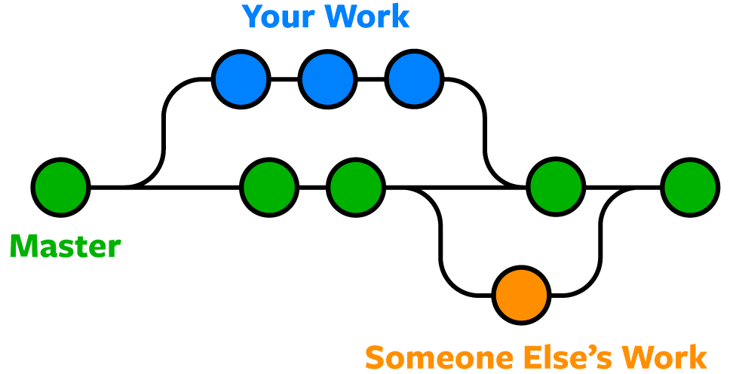

**Control System:**

This basically means that Git is a content tracker. Git can be used to store content

it is mostly used to store code or files due to the other features it provides.

**Version Control System:**

The code which is stored in Git keeps changing as more code is added. Also, many developers can add code in parallel. So Version Control System helps in handling this by maintaining a history of what changes have happened. Also, Git provides features like branches and merges, which I will be covering later.

**Distributed Version Control System**:

Git has a remote repository which is stored in a server and a local repository which is stored in the computer of each developer. This means that the code is not just stored in a central server, but the full copy of the code is present in all the developers’ computers. Git is a Distributed Version Control System since the code is present in every developer’s computer. I will explain the concept of remote and local repositories later in this article.

**Git vs Git-Hub**

**Git:**

* It is software install in locally on system.
* It is maintained by Linux.
* It can manage source code entire history.
* It is open-source license.

**Git-Hub:**

* It is a service which is hosted on a web exclusive cloud based.
* It is maintained by Microsoft.
* It is a hosting service for git repository.